**NetExam Chatbot**

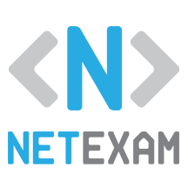

**User Guide**

**R & D Project**

**Introduction**

In this document discuss about NetExam chatbot, that implemented by using IBM Watson Assistant Services. IBM Watson Assistant is not just rule-based, it can connect to Watson Discovery so that it can answer questions which are beyond the existing rules. Following links, I preferred to implement NetExam chatbot.

IBM Watson Chatbot Tutorial: <https://cognitiveclass.ai/courses/how-to-build-a-chatbot/>

API Documentation: <https://cloud.ibm.com/apidocs/assistant-v2>

First, we have to create account in IBM cloud. Following image show Dashboard UI of IBM cloud account.

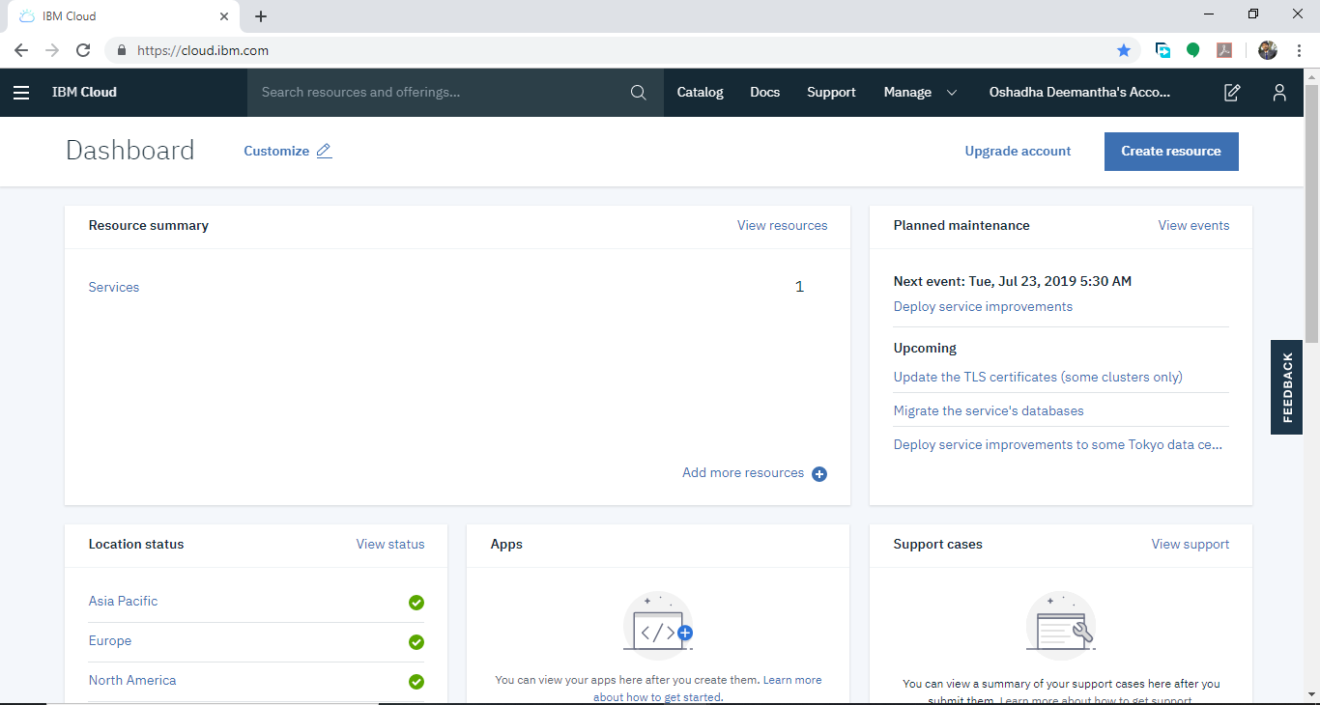

Then we have to create resource of Watson assistant. Above video tutorials are very helpful for setup Watson assistant service.

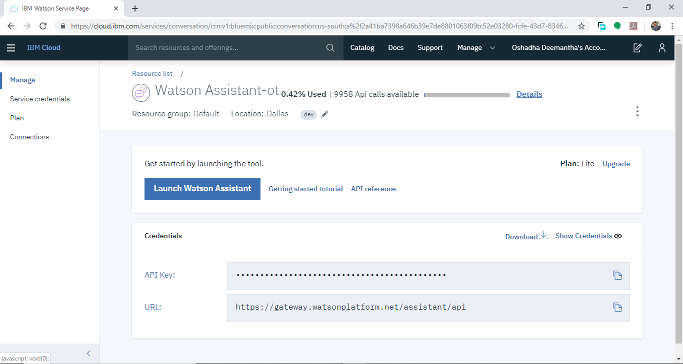

**How to train chatbot for new Question**

After create chatbot, we have to give skills to him for perform like a human. Our NetExam chatbot have a skill about NetExam system. So, we have to implement skill using flowing tool.

We have to create intents, entities and dialogs. Use above tutorial for understand intents, entities, and dialogs clearly it is easy to implement NetExam skill.

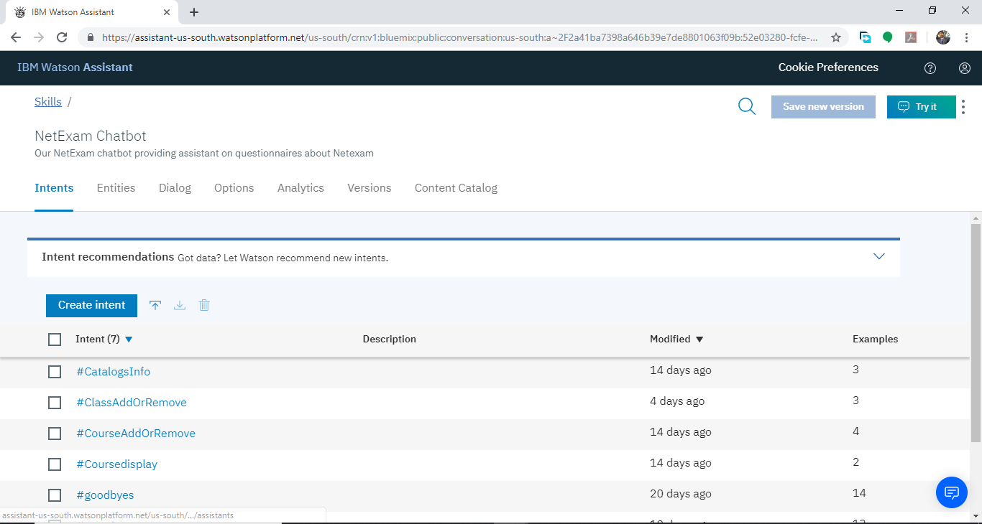

IBM Watson Cloud is Restful service. Therefor I have created Web API for access IBM Watson Cloud. Flowing image show about sample web application that include NetExam Chatbot. In that image you have to click button at the bottom of the page.

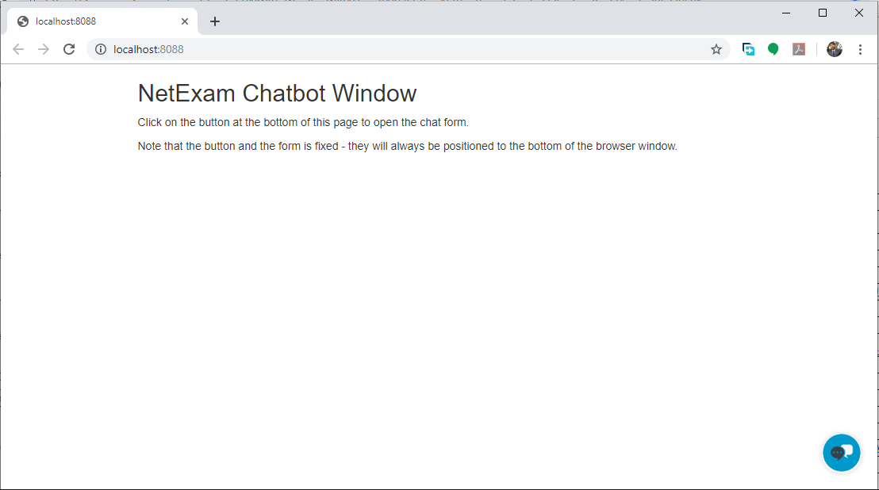

After that NetExam chatbot message box will be open. And also, we can see welcome message from chatbot.

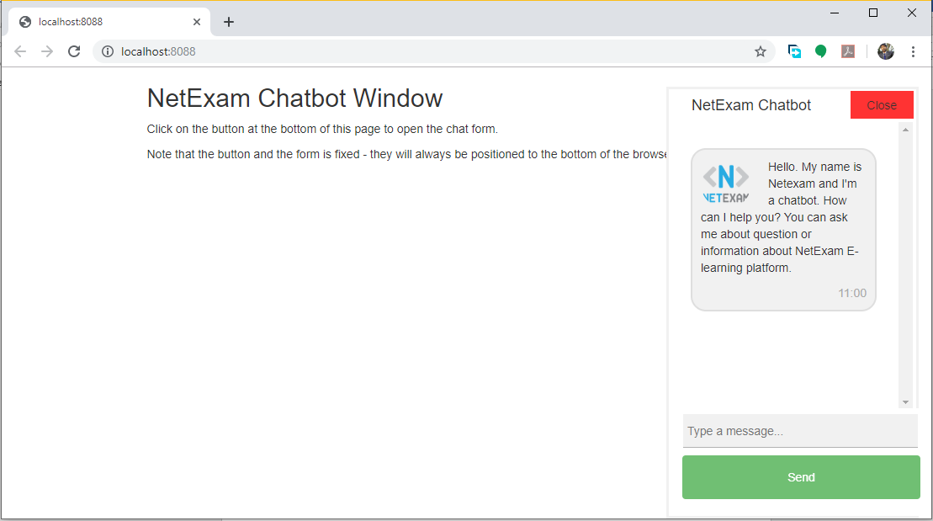

Now you chat with chatbot about question of NetExam system. First, I simply say “Hi” to chatbot.

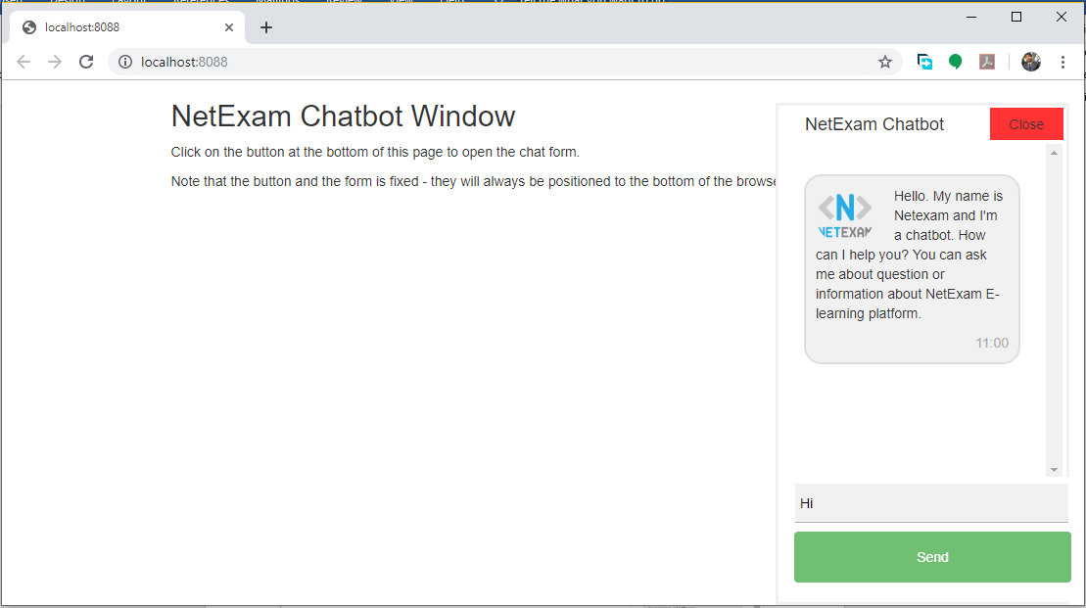

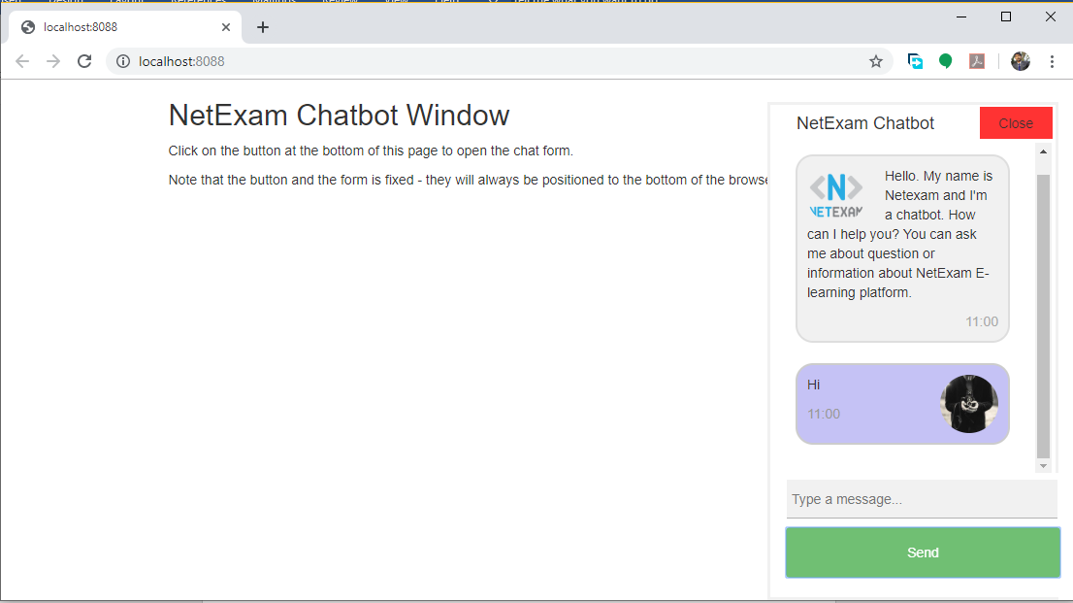

Then chatbot reply as following image

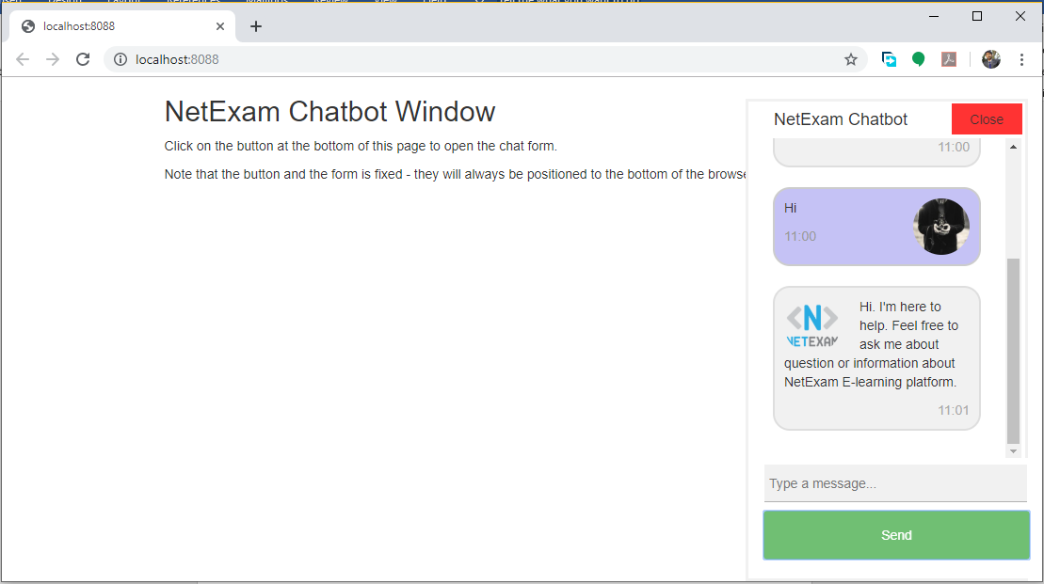

Like wise we can chat with NetExam chatbot about questions NetExam. Following image show screen shots of sample application, show some example question and example answers that chatbot give for user.

